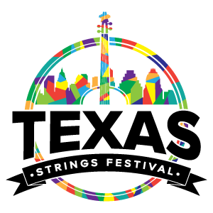

Texas Strings Camp Packing List
Clothing |  | Toiletries
Concert Dress (White shirt & black pants/skirt)  Black Dress shoes & socks  Comfortable walking shoes & socks  Tennis shoes/athletic wear  Day clothes  Undergarments  Bathing suit  Light jacket or sweater  Towels x 2  SHEETS! (Full or Queen set) |  | Shampoo and conditioner  Body wash/soap  Hair styling products & brush  Deodorant  Toothbrush, toothpaste, and floss  Flip flops to wear in showers  Glasses, contact lenses & solution

Important Items |  | Medical
Your instrument ;)  Solo & chamber music printed & learned  Music stand & pencil  Smartphone/tablet  Chargers  Check for tuition balance |  | Prescription medications (including inhalers)  Hand sanitizer  Sunscreen  Lip balm

Extras (Optional)
Spending $$
Extra Snacks (non-perishable only)
Change for washer/dryer
Smartphone/tablet

**Feel free to add and remove things based on your needs!
**Each dorm floor has a washer and dryers that are $1.50/wash and $1.00/dry. These are operated by credit card and coins.

